### C++ Basic Input/Output & More:

#### Basic Input and Output in C++:

C++ language comes with different libraries, which helps us in performing input/output operations. In C++ sequence of bytes corresponding to input and output are commonly known as streams. There are two types of streams:

##### **1.Input stream:**

In the input stream, the direction of the flow of bytes occurs from the input device (for ex keyboard) to the main memory.

##### **2.Output stream:**

In output stream, the direction of flow of bytes occurs from main memory to the output device (for ex-display)

#### Practical Explanation of Input/Output

We will see the actual code for input/output, and it's working. Consider the code below:

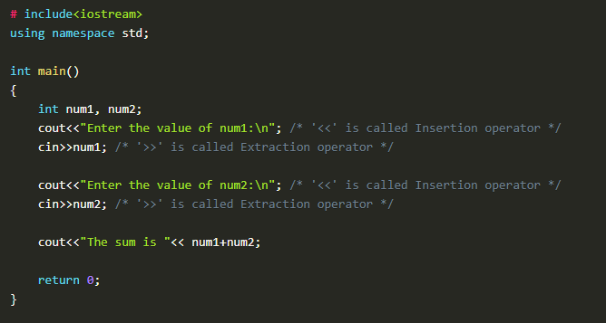

***Figure 1: Basic input/output program***

In this piece of code, we have declared two integer variables "**num1"** and "**num2"**. Firstly we used "**cout"** to print "**Enter the value of num1**:" as it is on the screen, and then we used "**cin"**to take the input in "**num1"** at run time from the user.

Secondly, we used "**cout"** to print "**Enter the value of num2**:" as it is on the screen, and then we used "**cin"**to take the input in "**num2"** at run time from the user.

In the end, we used "**cout"** to print "**The sum is"** as it is on the screen and also gave the literal "**num1+num2"** which will add the values of both variables and print it on the screen.

The output of the following program is shown in figure 2.

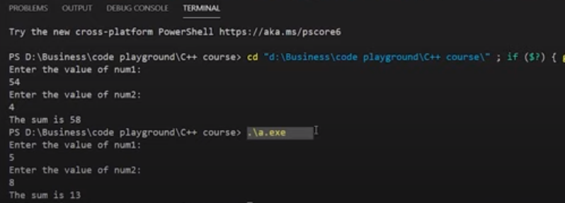

***Figure 2: Output of the Program***

 We have executed our program two times, which can be seen in figure 2. In our 1st execution, we had input the value "**54"** for the variable "**num1"** and value "**4"** for the variable "**num2"**. This gives us the sum of both numbers as "**58"**.

In our 2nd execution, we had input the value "**5"** for the variable "**num1"** and value "**8"** for the variable "**num2"**. This gives us the sum of both numbers as "**13"**.

#### Important Points:

1. The sign "**<<"** is called insertion operator
2. The sign "**>>"** is called extraction operator
3. "**cout"** keyword is used to print
4. "**cin"** keyword is used to take input at run time.

#### Reserved keywords in C++:

Reserved keywords are those keywords that are used by the language itself, which is why these keywords are not available for re-definition or overloading. In short, you cannot create variables with these names. A list of reserved keywords is shown in figure 3.

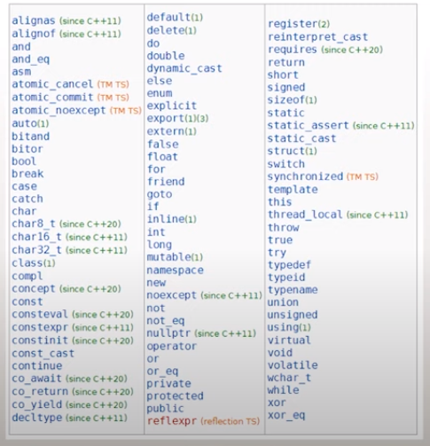

***Figure 3: Reserved keywords in C++***

#### Code as described/written in the video

# include<iostream>

using namespace std;

int main()

{

int num1, num2;

cout<<"Enter the value of num1:\n"; /* '<<' is called Insertion operator */

cin>>num1; /* '>>' is called Extraction operator */

cout<<"Enter the value of num2:\n"; /* '<<' is called Insertion operator */

cin>>num2; /* '>>' is called Extraction operator */

cout<<"The sum is "<< num1+num2;

return 0;

}